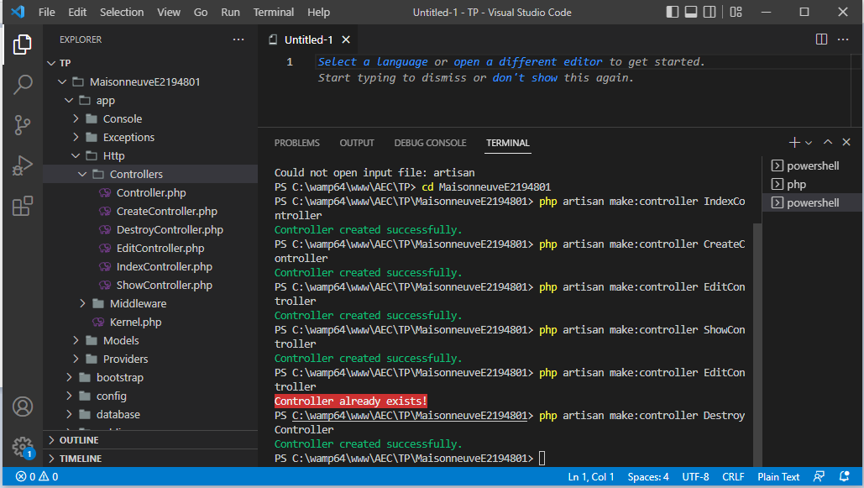

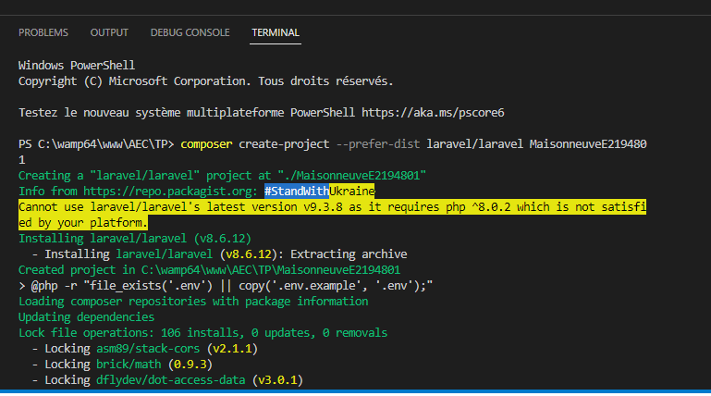

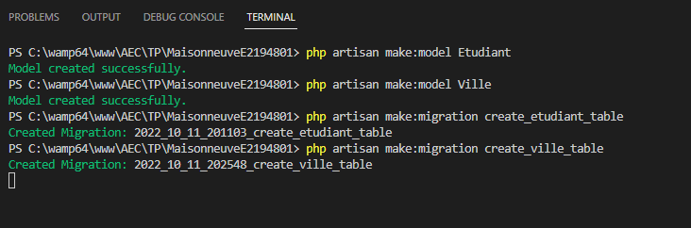

php artisan make:model Etudiant

php artisan make:model Villes

**Factory :**

Etudiant::factory()->count(15)->create()

Villes::factory()->count(15)->create()

**Lien Git;**

<https://github.com/WoodTheWebNinja/AEC.git>